WAR 126 Memory Drawing

Students sit back-to-back one student reads a description of a drawing, the other student draws the description on a plain A4 sheet of paper. = Must be to scale and accuracy is important
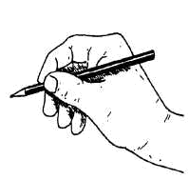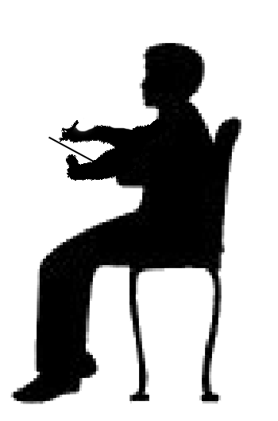

Here are the drawings pick one! All are A4
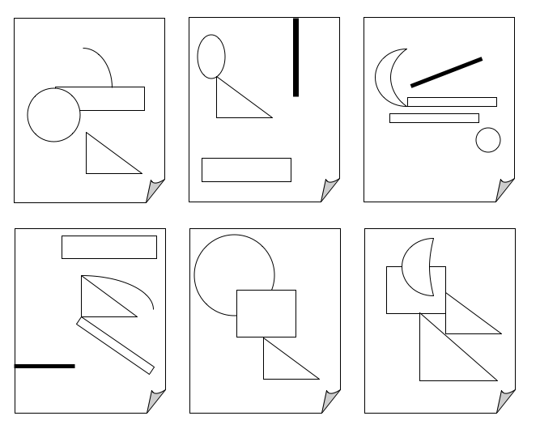
1
2
3
4
5
6



